Assessment of the performance of eight filtering algorithms by using full-waveform LiDAR data of unmanaged eucalypt forest

Gil Gonçalves*†‡ and Luísa Gomes Pereira§¶

†INESCC, Instituto de Engenharia de Sistemas e Computadores de Coimbra,

‡Faculty of Sciences and Technology of the University of Coimbra, PORTUGAL

§Higher School of Technology and Management of Agueda, University of Aveiro,

¶Research Centre for Geo-Spatial Sciences, University of Porto, PORTUGAL

Abstract: In this study the strengths and weaknesses of eight filtering algorithms are evaluated by using the mean, standard deviation and RMSE metrics. Seven of these algorithms are implemented in the freeware software ALDPAT (Airborne LiDAR Data Processing and Analysis Tools) and the eighth, the adaptive Triangular Irregular Network (TIN) also known as the Axelsson filter, in the commercial software Terrascan. The referred metrics are calculated by using DTM of topographic surfaces with quite different morphologies and vegetation covers. Forty-five of these surfaces, on circular plots of 400 m² each, are covered by brushwood and unmanaged eucalypt forest with different stand characteristics. The mean tree density is around 1600 trees per hectare. The DTM used to assess the DTM produced by filtering full-waveform LiDAR data using the 8 filtering algorithms are created with the help of a total station and geodetic GNSS receivers. The results show that the Terrascan and the so-called Polynomial two surface fitting filters give the best results, in terms of RMSE, in both forest and non-vegetated areas. Nonetheless, the results also show that all the 8 tested filters are suitable to use for the filtering of full-waveform LiDAR data, to be used in forestry related work, and collected over areas with great amount and high brushwood, chaotic eucalypt tree distribution and high tree density.

Introduction
The characteristics of data collected by small footprint LiDAR systems have proved to be adequate to derive estimates of several 3D vegetation structure metrics (such as canopy height, canopy base height, crown diameter). The estimation of these metrics requires the separation of the ground surface from the vegetation on it. The ground surface, represented by a Digital Terrain Model (DTM), is obtained by the automatic filtering of the laser-point cloud. This filtering process is a key issue for the computation of vegetation heights. Errors in DTM may result in erroneous vegetation structure metrics, which may have unforeseen repercussions.
During the last decade several filtering algorithms have been proposed with the intent to cope with different types of landscapes (urban and forest), and terrain morphologies. While a general understanding of the accuracy of the LiDAR systems has been achieved, the accuracy of the derived DTM from LIDAR data in a forest environment has not been thoroughly evaluated (Hodgson and Bresnahan, 2004; Reutebuch et al., 2003), mainly in unmanaged eucalypt forests. Indeed, while in the recommendations of the work of (Hyyppä et al., 2008) it is said that the extraction of DTM for forest areas is well established, this conclusion is based on a list of works using other forests than eucalypt forests. Moreover, the full-waveform data have, in comparison to conventional pulsed LiDAR data, the advantage of echo detection being done in post processing making the ranging process more robust. While this is expected to lead to higher accuracy of the derived distances and thus to a more accurate DTM (Ullrich et al., 2008), it remains to be proved in areas with the characteristics of the one here studied.
The few published works on the assessment of the performance of LiDAR filtering algorithms mainly address the statistics of omission and commission errors of the filtered data and not the geometric quality of the derived DTM with respect to an external reference. Huising and Gomes Pereira (1998) mentioned an error of 15 cm for the standard deviation of height differences on flat, bare terrain and identified some problems that may exist in the filtering process. Sithole and Vosselman (2004) conducted an experimental comparison of eight filters to evaluate their performance. The performance was assessed mainly by generating error matrices and by spatial representation of these error matrices in 15 subsets of the dataset. Zhang and Whitman (2005) compared three filters by using three LiDAR datasets collected on urban flat areas, coastal areas on smooth terrain and mountainous areas and by testing their sensitivity to the filters parameters. Seo and O’Hara (2008) compared three filter algorithms that exploit morphological operations, progressive TIN densification and kriging and by computing the omission and commission errors and RMSE for three LiDAR datasets (collected on residential areas on smooth terrain, residential areas on hilly terrain and commercial areas on moderate terrain relief). In order to compute the RMSE values they used reference surfaces interpolated from the manually filtered ground points.
Although the comparison of the performance of several filter algorithms has been assessed quantitatively by using the omission and commission errors, this procedure becomes impractical to use when the data are collected in unmanaged forested areas with high point densities (>1 pts/m²). This is because the manually classification of the millions of points involved in a single survey is an unfeasible task.
In this paper it is assessed the performance of eight filtering algorithms by using full-waveform high density LiDAR point clouds (> 10pts/m2) of an unmanaged eucalypt forest. Seven of these algorithms are implemented in the freeware software ALDPAT (Airborne LIDAR Data Processing and Analysis Tools) and the eighth, the adaptive Triangular Irregular Network (TIN) also known as the Axelsson filter, in the commercial software Terrascan. Their strengths and weaknesses are investigated by using DTM produced for topographic surfaces with quite different morphologies and vegetation covers. Forty-five of these surfaces, on circular plots of 400m2 each, are covered by brushwood and unmanaged eucalypt forest with different stand characteristics. The mean tree density is around 1600 trees per hectare. The DTM used to assess the DTM obtained with the 8 filtering algorithms are produced with the help of a total station and geodetic GNSS receivers. The results show that the adaptive TIN filter, implemented in Terrascan software, gives the best results, in terms of RMSE, in both forest and non-vegetated areas. The results obtained for the forest area – among which it should be mentioned a RMSE of 15 cm - are quite surprising when considering the great amount and height of brushwood, the chaotic tree distribution and high tree density over the majority of the plots.

Study area and data
The study area was selected nearby the city of Águeda, in the district of Aveiro, situated in the Northern part of Portugal. The selected area measures 900 ha (Figure 1-a). The topography of the study area varies from gentle to steep slopes, with altitudes varying from 27 to 162 m (Figure 1-b). Being the area dominated by eucalypt plantations, it also includes some pine stands and few built-up areas. The mean tree density is around 1600 trees per hectare. The forest stands in the area comprise regular as well as irregular spacing plantations, both even and uneven-aged stands, and stands with as well as without extensive undergrowth (Figure 1-c).
The LiDAR data were acquired on the 14th of July of 2008. The laser system utilized was the Litmapper 5600, operating with a pulse repetition frequency of 150 KHz, an effective measurement rate of 75 KHz and using a half-angle of 22.5º. Thirty overlapping strips (70% of sidelap) were flown from an average flying height above the ground of 640 m with an average single run density of 3.3 pt/m². The full-waveform laser data were processed with the RiAnalyze software from Riegl. A maximum of 5 returns were obtained with a minimum vertical separation of 50 cm and the average values of laser footprint and point density were 30 cm and 10 pts/m² respectively.
Reference data are needed to verify, in terms of precision and reliability, the DTM produced by means of the laser data and a filtering algorithm. The strategy for the reference data collection was not straightforward. In forest areas, the collection of these data is time consuming, mainly in plots with a high density of shrubs and trees. Furthermore, because the data were georeferenced, geodetic GNSS receivers had to be used. The planning of the topographic survey was based on that of the forest inventory. The DTM was represented by the coordinates of terrain points located aside trees, which give also the locations of the trees, and by the coordinates of prominent terrain points, like those on breaklines. This information was collected by means of a topographic survey using the irradiation method. The coordinate system in which the LiDAR and image data were collected is the WGS84 UTM zone 29, for X and Y coordinates, and the WGS84 ellipsoidal height for the Z coordinate (from now on referred to as absolute coordinates X, Y and Z). Because this is not a local system, the geographic information collected in the field had to be converted to that system by using the Global Positioning System (GPS). To this end, it was decided to attach to each plot two points, named GPS base, whose coordinates were measured with two GNSS receivers. These two points were placed as close as possible to the plot and as much as possible in an opened space. This criterion turned out to be difficult to fulfil in the study area. Finally, 3174 points were measure on 43 circular plots using this methodology.
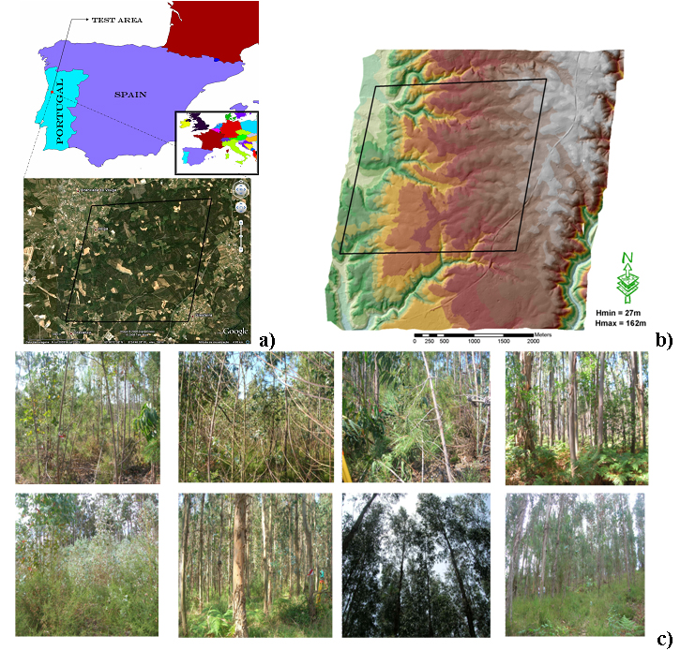
Figure 1: (a) Localization of study area within Portugal and its delimitation; (b) DTM of the
study area; (c) Examples of vegetation covers inside plots.

Filtering methods
As stated above, seven of the eight filters tested are implemented in the free software ALDPAT®. The eighth filter is the well known Axelsson filter (ATINT) which is implemented in the TerraScan® software. A short description of each filter, as well as of its basic parameters are presented underneath.
1. Elevation threshold with expand window (ETEW) - This filter uses the concept of minimum height value inside a square window with growing sizes to label the ground points. The main parameters used by the filter are:
- Cell size (c): Initial cell size for gridding the point cloud.
- Terrain slope (s): slope factor used for calculating the threshold value of the elevation differences between the point with minimum elevation value (Z_{min}) and any other Z_{j} point locate inside the search window, , where c_{i} is current cell size (which is twice of the previous iteration). For the i^{th} iteration the point j is labelled as ground point if
- Number of iterations (i): number of iterations used by the filter.
2. Iterative polynomial fitting (IPF) - With this filter the LiDAR points are classified into ground points by selecting iteratively the ground measurements from the original point cloud inside a size decreasing moving window. A candidate point (lowest point inside the moving window) is added to the set of ground points if the elevation difference between the elevation of this point and that at the same planimetric location given by the polynomial fitted ground surface is less than a pre-defined threshold (th). In each iteration, the ground points used for the surface fitting with piecewise polynomials are selected as the lowest points within the moving window. For the sake of simplicity the cloud point is converted to a grid format and all the filtering process is done over this minimum elevation grid. The main parameters of this filter are:
- Cell size (c): cell size used in each iteration for the fitting of the piecewise polynomial surface to the ground points.
- Height threshold (th): vertical difference between the elevation of a point and that at the same planimetric location given by the fitted ground surface.
- Outlier tolerance (to): vertical difference between the elevation for a point and that computed at the same planimetric location by using the final interpolated ground surface.
- Initial window size (wi): Initial size of the moving window used to select the ground points. In the first iteration the points with minimum elevation falling within the window are selected as ground points. For the remaining iterations the moving window is centred over each grid node and the minimum elevation point within the window is selected as a ground candidate.
- Number of windows (wn): number of windows (or iterations).
- Windows sizes (ws): the various windows sizes used in each iteration. Although the current window size can be set automatically as half of its previous size the size of each window can be chosen individually.
3. Polynomial two surface fitting (P2Surf) - This filter is an extension of the previous IPF filter and uses two polynomial fitting surfaces. In order to remove the omission errors (ground points classified as non-ground) the difference in elevation between that of a candidate point (or cell) and that of the current surface is calculated and compared with a predefined threshold. To remove the commission errors (non-ground points classified as ground) the fitness of the current and of the previous surface to the ground points are compared to a predefined threshold. A candidate point that falls within a given interpolation window (iw) is added to the set of ground points if the fitness of the current surface is better than that of the previous fitting surface within this fitting window. The parameters used by this filter are very similar to those of the previous one except the following:
- Sigma difference (sig): the fitness of the current and previous polynomial surfaces to the ground points (i.e cells).
- Neighbour Range (nr): radius of the neighbour search window.
- Interpolation window (iw): size of the window used in the fitting operation.
- Power (p): exponent of the polynomial function used for fitting the ground surfaces (current and previous).
4. Maximum local slope (MLS) - This filter uses the assumption that between any two points the terrain slope is usually different from the slope between the ground and the tops of trees or the top of buildings. The algorithm implemented in the ALDPAT software is similar to the algorithm described by Vosselman in [6]. A point p_{i} of a given point cloud V is classified as ground if the maximum value of slopes between this point and any other point p_{j} located in the circular neighbourhood of p_{i} with radius r () is less than the predefined slope threshold (s). That is, denoting by d_{ij} the Euclidian distance between the two points p_{i} and p_{j}:
The main parameters of this filter are:
- Cell size (c): the cell size used to create the minimum elevation grid.
- Minimum distance (d): minimum separation between points allowed in slope computation.
- Maximum Slope (s): the slope threshold used in the labelling process.
- Search Radius (r): the size of the search window.
5. Progressive morphology 1D (PM1D) - This filter is the progressive morphological (PM) filter presented in [7], and uses successive morphological openings for removing from the ground the non-ground objects of varying sizes. In each iteration (i) an opening (erosion + dilation) is performed on the previous opened surface. A cell j is classified as ground if the elevation difference between the previous (i-1) and current surface (i) is smaller than the height threshold:
where is an initial elevation threshold to allow for small ground variation, s is the predefined maximum terrain slope, c is the cell size and is the size of the structuring element (window size) at i^{th} iteration. This structural element used by the PM filter can be either 1D (line segments) or 2D (squares or circles). The main parameters of the PM1D filter are:
- Cell size (c): value used to subdivide the point cloud into an array of square cells of size c, where all the points, except the points with minimum elevation, are discarded.
- Slope (s): value used to compute the elevation difference threshold given in equation .
- Height threshold (th): maximum elevation difference between terrain and ground objects.
- Number of windows (wn): number of iterations (i.e morphological openings).
- Windows sizes (ws): sizes of windows used in the successive openings. For each iteration this size can be calculate as , where b is the base of an exponential function.
- Neighbour Range (r): search radius used in the initial nearest neighbour interpolation for filling the empty cells.
6. Progressive morphology 2D (PM2D) - In this case the structural element use to perform the morphological erosion and dilatation operations is a square window of size (ws). The main parameters of this filter are very similar to the parameters of the previous PM1D filter.
7. Adaptive TIN (ATIN) - The main concept used in this filter was originally developed by Axelsson (see the ATINT filter) and modified slightly as follows: i) the point cloud is projected onto a grid of cell size (c) and for each cell the point with minimum z value is kept; ii) By projecting this new point cloud onto a grid of cell size (Ic) and by selecting for each cell the point with minimum z value a sparse TIN is obtained from these seeds points using the Delaunay triangulation algorithm; iii) this TIN is progressively densified by adding one ground point at a time to each Delaunay triangle. A point is added to the triangle in each iteration if its distance to the triangle surface is less than a predefined threshold (th). An angle threshold (ta) may be also used to control the inclusion of a point close to a ground point with a steep slope. In this case it is necessary to calculate for each point the maximum of three angles between the triangular surface and the lines connecting the point and the vertices of the triangle.
8. Adaptive TIN in TerraScan® (ATINT) - The basic assumption of this method is that the terrain relief can be locally and globally approximated by triangular facets. As mentioned previously this algorithm starts by creating a coarse TIN based on the seed points which are chosen as the points of minimum elevation within a given square neighbourhood. This TIN is then densified in an iterative process by adding one point at a time to each TIN facet. This is only carried out if two criteria are met concerning the distance and the angle above referred which are compared against thresholds (th and ta, respectively; see below). It seems that the differences of this implementation as compared to the previous implementation are: i) it works with the original point cloud; ii) in each iteration statistics from the points classified as ground are collected in the form of histograms of surface normal angles and elevation differences. These histograms are used to update the values of the thresholds used in the iterative process. The main parameters of this filter are:
- Initial window size (wi): window size to select the seeds points (size of the largest structure).
- Terrain slope (s): steepest allowed slope for the ground surface.
- Height threshold (th): maximum distance between the candidate point and the triangle plane.
- Angle threshold (ta): Maximum angle between the candidate point, its projection on triangle plane and closest triangle vertex.

Procedure to assess the performance of the filters
The filters performances are assessed by estimating the accuracy of the DTM produced by filtering the LiDAR data. This accuracy assessment relates to the estimation of the mean, standard deviation and RMSE of the differences (dz; from now on named residuals) between the Z values of the reference points () and those at the same planimetric locations of the LiDAR terrain points ().
These LiDAR terrain points are interpolated from a TIN computed with the filtered LiDAR terrain points. It was decided to create a TIN from the filtered LiDAR data instead of from the reference data because the density of LiDAR terrain points is higher than that of reference points (3.8 versus 0.2 points/m²). The higher density of LiDAR terrain points per m² than that of the reference points implies that points on the terrain are represented in the LiDAR filtered data but not in the reference data. Therefore, it is more adequate to interpolate the laser data to the planimetric positions of the reference data. The TIN format is also more appropriate than the grid format once the interpolated height is influenced only by the unaltered height values of its neighbours (3 neighbours when linear interpolation is used). The accuracy of the DTM obtained with the LiDAR data was computed for each plot (radius = 11.28) individually and collectively, by adopting the strategy above detailed.
Table 1 shows the values of the main parameters used in the filtering process for the eight filters above listed. These values were tuned experimentally by using a trial-and-error approach and by evaluating the quality of the resulting surface visually through shaded relief techniques.
Table 1: Parameters used in the 8 filters for the 43 plots.
-- | c | s | th | ta | to | sig | wi | wn | ws | r | iw
ETEW | 0.2 | 0.25 | 0.2 | -- | -- | -- | -- | 5 | [0.2 0.4 0.8 1.6 3.2] | -- | --
IPF | 0.2 | -- | 0.1 | -- | 0.05 | -- | 10 | 4 | [10 5 2 1] | -- | --
P2Surf | 0.4 | -- | 0.1 | -- | 0.05 | 0.01 | 10 | 4 | [10 5 2 1] | 10 | 5
MLS | 0.2 | 0.25 | 0.2 | -- | -- | -- | -- | 5 | -- | -- | --
PM1D | 0.2 | 0.01 | 0.1 | -- | -- | -- | 1 | 5 | [0.2 0.4 0.8 1.6 3.2] | -- | --
PM2D | 0.2 | 0.2 | 0.2 | -- | -- | -- | 1 | 5 | [0.2 0.4 0.8 1.6 3.2] | -- | --
ATIN | 0.4 | -- | 0.1 | 10 | -- | -- | 10 | -- | -- | -- | --
ATINT | -- | -- | 1.4 | 6 | -- | -- | 10 | -- | -- | -- | --

Results and final considerations
In Figure 2, Figure 3 and Figure 4 are shown, respectively, the estimated values for the mean, standard deviation and RMSE, of the residuals obtained in the 43 circular plots of radius 11.28 m and by using the eight LiDAR filters.
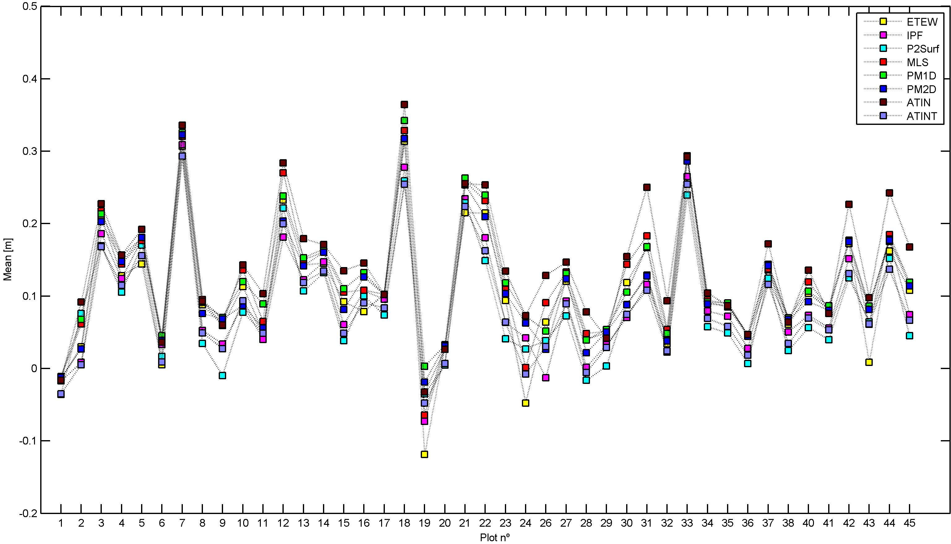
Figure 2: Values of the Mean of residuals per plot for the eight filters.

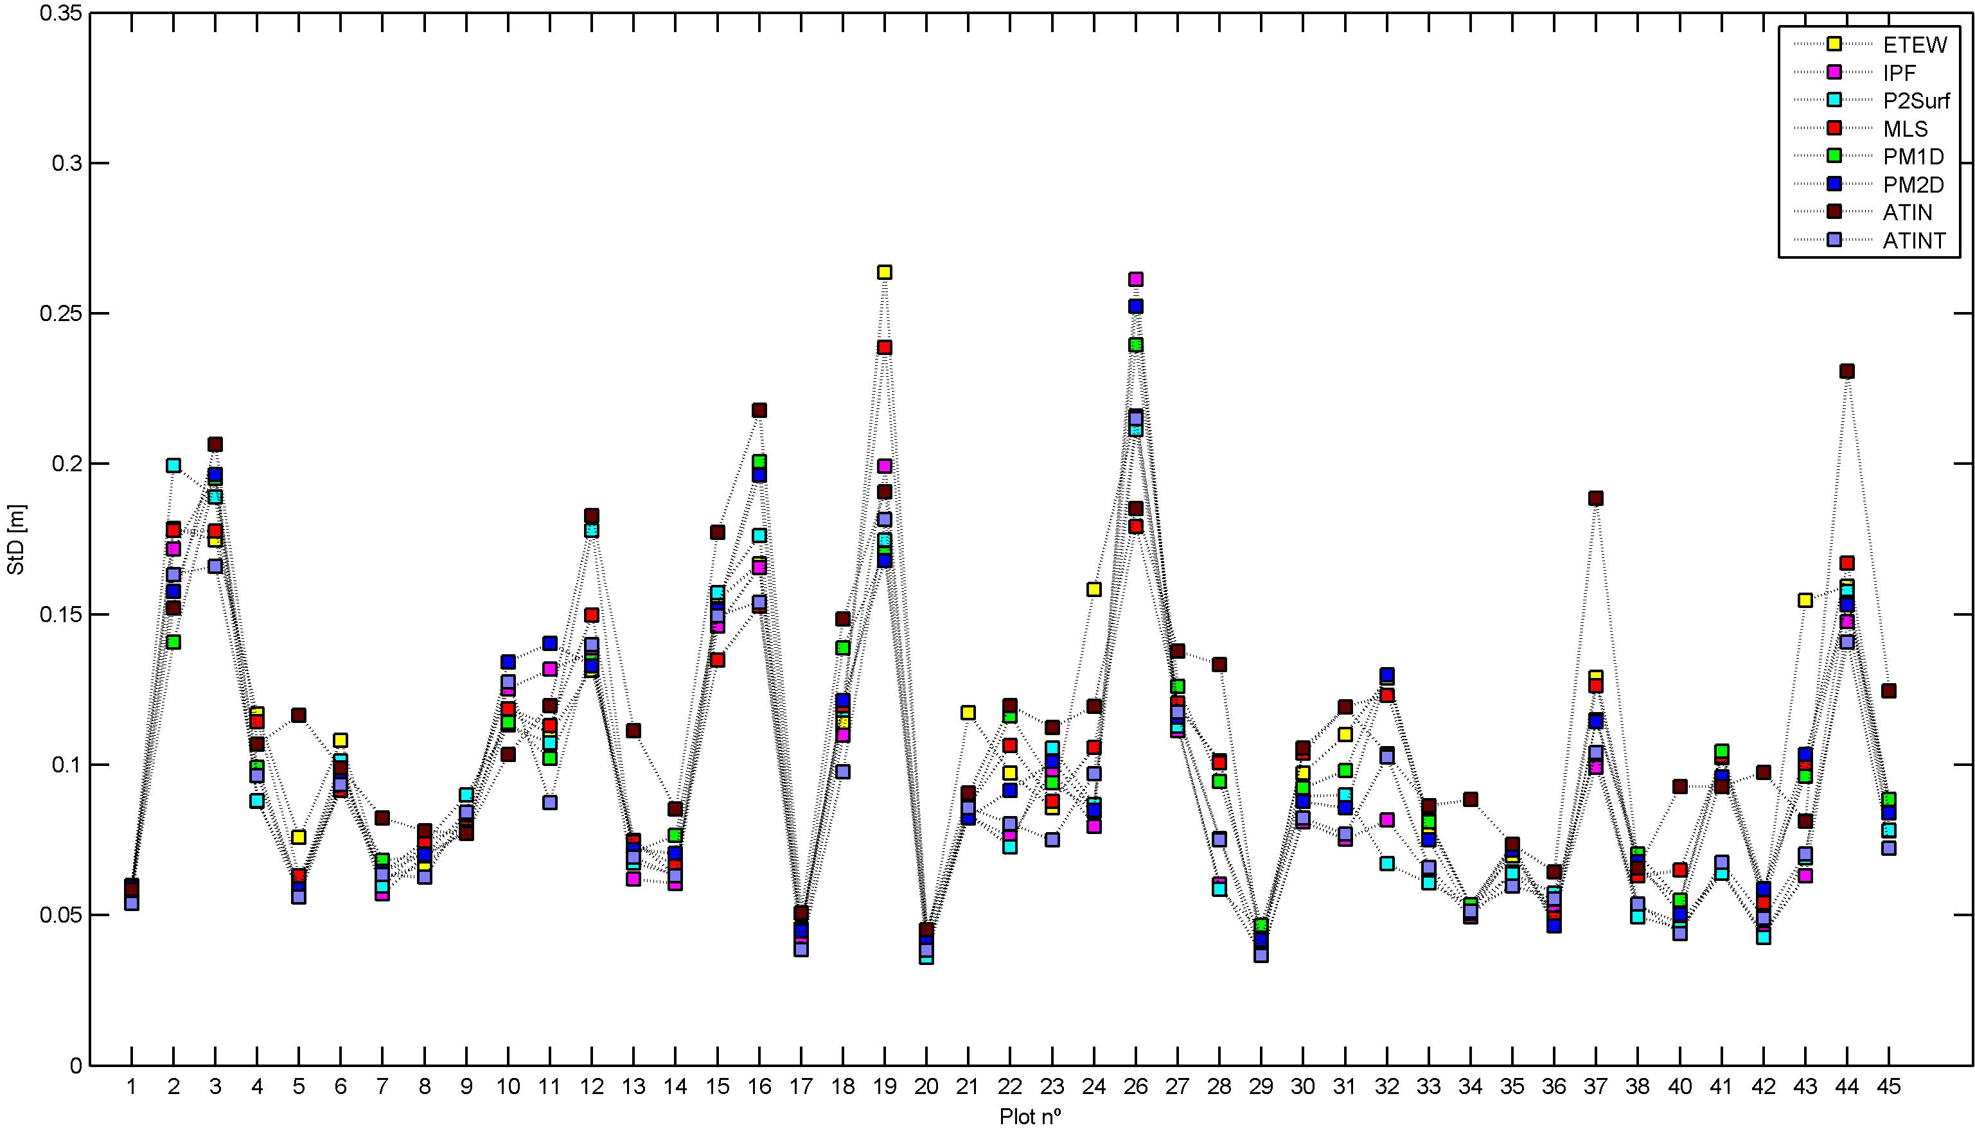
Figure 3: Values of the Standard deviation (STD) of residuals per plot for the eight filters.
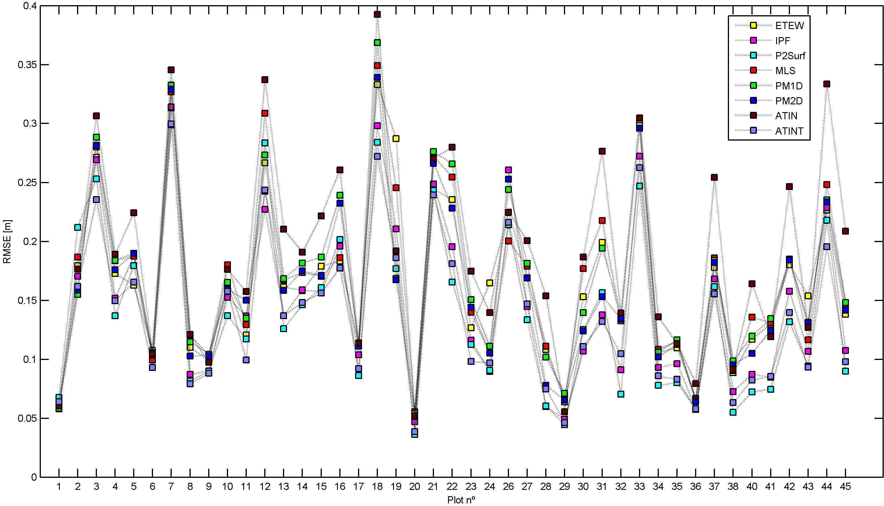
Figure 4: Values of the RMSE of residuals per plot for the eight filters.
Table 2 shows the same results for the eight filters when considering all the plots together, i.e., the 3 174 control points located over the 43 circular plots.
Statistical parametric tests of hypotheses were carried out to compare the mean and standard deviations of the residuals. By using a 5% level of significance the null hypothesis, i.e., the assumption that the mean values are equal was rejected (except for the mean of residuals obtained by using the P2Surf and ATINT filters). For the same level of significance, the standard deviation values of the filters P2Surf and ATINT are statistically equal and smaller than those obtained by using the other filters. These results show that both filters P2Surf and ATINT have similar performances, which are superior to those of the other filters. The ATIN filter, which is a different implementation of the Axelsson algorithm (i.e a different version of the ATINT filter) has surprisingly the worst performance. In spite of these conclusions, the differences in the accuracy of the various DTM (maximum 6 cm) are not significant for work carried out in a forest environment.
Therefore, all the 8 tested filters are suitable for the filtering of full-waveform LiDAR data collected in areas with great amount and high brushwood, chaotic eucalypt tree distribution and high tree density.
Table 2: Mean, standard deviation and RMSE values of residuals obtained by using the eight filters on LiDAR data within the 43 plots together.
 | ETEW | IPF | P2Surf | MLS | PM1D | PM2D | ATIN | ATINT
Mean | 0.10 | 0.09 | 0.08 | 0.12 | 0.12 | 0.11 | 0.14 | 0.08
STD | 0.15 | 0.14 | 0.13 | 0.14 | 0.14 | 0.14 | 0.15 | 0.13
RMSE | 0.18 | 0.16 | 0.16 | 0.18 | 0.18 | 0.18 | 0.21 | 0.15

Acknowledgments
The present study was funded by the Foundation for Science and Technology (FCT) of Portugal in the framework of the project PTDC/AGR-CFL/72380/2006 with co-funding by FEDER.
References
[1] Axelsson, P., 2000. DEM Generation from Laser Scanner Data Using Adaptive TIN Models, International Archive of Photogrammetry and Remote Sensing, Vol. XXXIII, Part B4, pp. 110–117.
[2] Hodgson, M., and Bresnahan, P. 2004. Accuracy of airborne lidar-derived elevation: empirical assessment and error budget, Photogrammetric Engineering & Remote Sensing, vol. 70, no. 3, pp. 331–340.
[3] Huising, E. and Gomes Pereira, L., 1998. Errors and accuracy estimates of laser data acquired by various laser scanning systems for topographic applications. ISPRS Journal of Photogrammetry and Remote Sensing, vol. 53, no. 5, pp. 245–261.
[4] Hyyppa, J., Hyyppa, H., Leckie, D., Gougeon, F., Yu, X., and Maltamo, M., 2008. Review of methods of small-footprint airborne laser scanning for extracting forest inventory data in boreal forests, International Journal of Remote Sensing, vol. 29, no. 5, pp. 1339–1366.
[5] Reutebuch, S., McGaughey, R., Andersen, H.-E. and Carson, W., 2003. Accuracy of a high-resolution lidar terrain model under a conifer forest canopy, Canadian Journal of Remote Sensing, vol. 29, pp. 527–535.
[6] Seo, S. and O Hara, C. 2008. Parametric Investigation of the Performance of LiDAR Filters Using Different Surface Contexts. Photogrammetric Engineering & Remote Sensing 74 (3), 343-362.
[7] Sithole, G. and Vosselman, G., 2004. Experimental comparison of filter algorithms for bare-earth extraction from airborne laser scanning point clouds, ISPRS Journal of Photogrammetry and Remote Sensing, Vol. 59, pp. 85–101.
[8] Soininen, A., 1999 ''TerraScan User’s Guide'', TerraSolid, 169 pags.
[9] Vosselman, G., 2000. Slope Based Filtering of Laser Altimetry Data, International Archives of Photogrammetry and Remote Sensing, Vol. XXXIII, Part B3, Amsterdam 2000, pp. 935–942.
[10] Zhang, K., Chen, S., Whitman, D., Shyu, M., Yan, J. and Zhang, C., 2003. A progressive morphological filter for removing non-ground measurements from airborne LIDAR data. IEEE Transactions on Geoscience and Remote Sensing, 41, 872-882.
[11] Zhang, K. and Whitman, D., 2005. Comparison of three algorithms for filtering airborne LIDAR data. Photogrammetric Engineering & Remote Sensing 71 (3), 313-324.

*Corresponding author. Email address: gil@mat.uc.pt

